Ranch Horse Association of Michigan
2018 Youth Representative Contest
Contestant guidelines:
- Must be current RHAM member in good standing.
- Open to boys and girls between the ages of 14 and 18 as of January 1, 2018.
- Must have never been married, divorced, or a single parent.
- Must not have been convicted of any crime.
- Must not be caught with drugs, alcohol, and/or tobacco products at any time while appearing on behalf of RHAM or at any ARHA show.
- Must not cohabitate with a significant other during your reign.
- Must not use profanity.
- Must communicate with Youth director.
- Must be in proper attire when representing RHAM.
- All contestants are to act in a respectable manner at all times. Contestants may be disqualified for behaviors that are considered inappropriate. The winner may also lose their title for inappropriate behavior.
- Contestants will not slander other contestants, judges, committee members or others involved with the RHAM or ARHA.
- Youth Representative will automatically be on next year’s RHAM Youth Representative Committee.
- Previous Youth Representative contest winners are encouraged to enter.
If at any time during the reign of RHAM Youth Representative these rules are broken, Youth Representative will forfeit their title/awards (buckle) and the 1st runner up will step into their place.
When in doubt, remember to follow the Code of the West!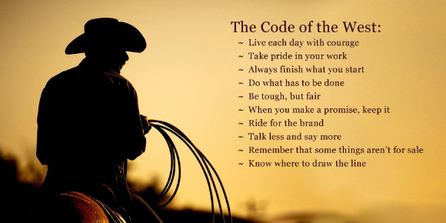

Judging/Contest
Judges will be selected for their expertise in all fields of competition. The scheduled judged activities may include essay, horsemanship, interview, speech and written test.

Based on the response/applications received by Youth Representative candidates, the RHAM Board of Directors will implement a fair and balanced competition for the candidates which may include but is not limited to: essay, horsemanship, interview, speech, written test.

The selected 2018 RHAM Youth Representative will be announced at the RHAM May show at Berrien Springs – May 12 & 13, 2018.

Duties during year of reign:
- Must at all times wear appropriate show attire while fulfilling official duties.
- The Youth Representative is to be available to participate in events to promote RHAM and ARHA during their reign. This includes the Mid-West Regional Show and the 2018 RHAM Banquet.
- Candidate must be able to conduct flag ceremonies at the opening of each RHAM show.
- Participate in fundraisers throughout year to raise money for future youth representative contests.

