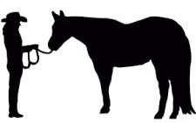
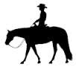
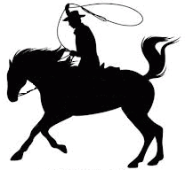
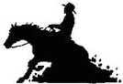
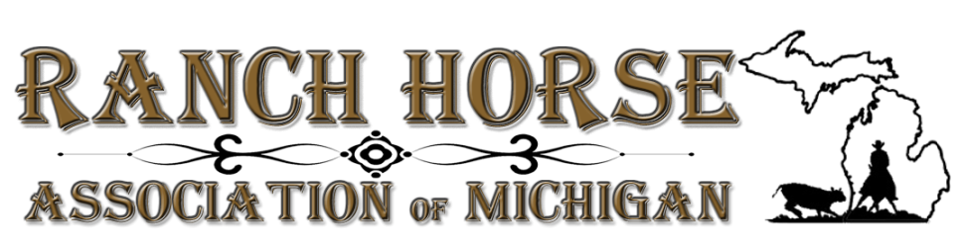
2024 Clinics
Cattle Clinic
This cattle clinic is for riders and horses who are familiar with cattle. Clinicians will focus on the aspects of proper working position, tracking and herd situations.
- Two (2) ½ day clinics will be offered.
  - Saturday, April 20, 2024 from 8am – 12pm ET/MI time
  - Saturday, April 20, 2024 from 1pm – 5pm ET/MI time
- 10 participant limit for each session.
- $275 fee for ½ day clinic.
Introduction to Ranch Horse
The clinicians will explain the various events held at a RHAM show and the differences between the events such as:
- Conformation vs. Halter
- Ranch Riding vs. Western Pleasure
- Reining vs. Ranch Reining
- Cutting vs. Ranch Cutting
- Working Cow Horse & Working Ranch Horse
Sunday, April 21, 2024 from 9:00am – 4:00pm (MI time)
  - 15 participant limit.
  - $325 fee.

Both clinicians show with at RHAM and are ARHA Professional members.
Dave DeWell | Dave McCartney
Stone Ridge Training Center  www.stoneridgetrainingcenter.com | Double Diamond Performance Horses  www.doublediamondquarterhorses.com
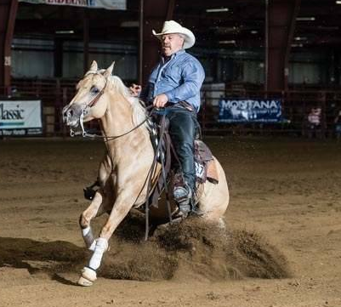

Clinics held at: Berrien County Fairgrounds Overnight camping and stalls available: $30.00 for electric
9122 Old U.S. 31, Berrien Springs, MI 49103 and $28.00 stall fee per night.
Participant limits: Participation limited per above and equates to Stalls to be CLEANED OUT PRIOR to departure or will be charged $28.00 per day plus cleaning fee.
one horse / one rider teams
Potluck lunch: RHAM will provide meat, water, plates and cutlery. AUDITORS & SPECTATORS WELCOME  DONATIONS ALWAYS APPRECIATED
Please bring a dish to pass.
For additional information: call, text or email either Sam Holwerda at 616-890-1190 / samholwerda@yahoo.com
CLINIC REGISTRATION FORMS can be found online under FORMS at www.miranchhorse.com

FEES MUST BE PAID AT TIME OF REGISTRATION  NO HOLDS WITHOUT FULL PAYMENT  CLINIC PAYMENTS ARE NON-REFUNDABLE  HELMETS ARE REQUIRED FOR ALL RIDERS 18 AND UNDER
NO STALLIONS  CURRENT PAID RHAM MEMBERSHIP WILL TAKE PRECEDENCE

UNDER THE MICHIGAN EQUINE LIABILITY ACT, AN EQUINE PROFESSIONAL IS NOT LIABLE FOR AN INJURY TO OR THE DEATH OF A PARTICIPANT IN AN EQUINE ACTIVITY RESULTING FROM THE INHERENT RISK OF THE EQUINE ACTIVITY.

